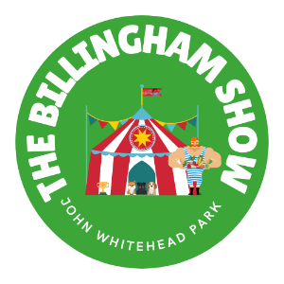**BILLINGHAM SHOW 2025**

**Non-Trader Participation Form**

**Event Details: The Billingham Show 2025**

**Date: Saturday 6th & Sunday 7th September 2025**

**Time: 10:00 AM - 4:00 PM daily**

**Location: John Whitehead Park, Billingham, TS23 2DD**

**Contact Information**

Full Name: ...........................................................................

Organisation (if applicable): .................................................

Address: ..........................................................................................................................................

Postcode: ...................................

Phone: ................................................

Email: ...............................................................................

**Participation Details**

Type of Activity/Display (please specify): .......................................

Space Required (approximate dimensions): .......................................

**Schedule Preference (please tick)**

□ Saturday 6th September only

□ Sunday 7th September only

□ Both days

**Requirements (please tick all that apply)**

□ Table(s) - Quantity: ___

□ Chairs - Quantity: ___

□ Covered Area

□ Vehicle Access for Setup

□ Other (please specify): .......................................

**Setup Information**

Preferred Setup Time (please tick)

□ Friday (time TBC)

□ Saturday morning (before 9:30 AM)

□ Sunday morning (before 9:30 AM)

**Additional Information**

Please provide any additional details about your display/activity:

...............................................................................................

...............................................................................................

...............................................................................................

**Public Liability Insurance**

Do you have Public Liability Insurance?

□ Yes (Please attach a copy with your application)

□ No

Insurance Provider: .......................................

Policy Number: .......................................

Expiry Date: .......................................

**Health & Safety**

Risk Assessment Provided?

□ Yes (Please attach with your application)

□ No

**Declaration**

I confirm that all information provided is accurate and I agree to comply with all event rules and regulations.

Signature: .......................................

Date: .......................................

**Please Return To:**

Email: kate.minza@billingham-tc.gov.uk

Office Use Only:

Date Received: ...........................

Application Number: ...........................

Approved By: ...........................